***ASSIGNMENT 3***

***NAME: Ashish Mukherjee***

***ROLL NO.: 2193060***

***CLASS: LY NS***

**ASSIGNMENT 3**

**AIM**- Configure SNMP agent and MIB on the network.

**CONFIGURATION** -

* Add a new network to the router
* Add a switch
* Add PCs
* Connect PCs to switch with fastethernet cable
* Connect router with switch with gigabitethernet cable
* Assign the IP address to the ports of the router
* Set no shutdown

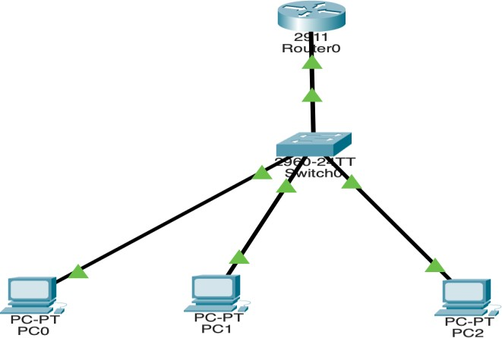

Figure 1: Network

# Router CLI commands:

Router>enable Router#

Router#configure terminal

Enter configuration commands, one per line. End with CNTL/Z. Router(config)#interface GigabitEthernet0/0

Router(config-if)# Router(config-if)#exit

Router(config)#interface GigabitEthernet0/1 Router(config-if)#

Router(config-if)#exit

Router(config)#interface GigabitEthernet0/0 Router(config-if)#

Router(config-if)#exit Router(config)#interface GigabitEthernet0/0

Router(config-if)#ip address 192.168.2.1 255.255.255.0

Router(config-if)#ip address 192.168.2.1 255.255.255.0 Router(config-if)#no shutdown

Router(config-if)#

%LINK-5-CHANGED: Interface GigabitEthernet0/0, changed state to up

%LINEPROTO-5-UPDOWN: Line protocol on Interface GigabitEthernet0/0, changed state to up

Router(config-if)#exit Router(config)#

Router(config)#snmp-server community Router ro

%SNMP-5-WARMSTART: SNMP agent on host Router is undergoing a warm start

Router(config)#snmp-server community Router rw Router(config)#

Router(config)#exit Router#

%SYS-5-CONFIG_I: Configured from console by console

Router con0 is now available Press RETURN to get started. R1>

# Explanation

* Configure router with SNMP community
* snmp-server community Router ro
* snmp-server community Router rw
* Router is password for SNMP

# MIB Configuration:

* Select MIB from any PC
* Enter the IP address of Router
* 192.168.2.1
* Go to advance
* Enter Router in Read community
* Enter Router in Write community

# Get Command:

**Set Command:**

Figure 2: Get Command using MIB interface

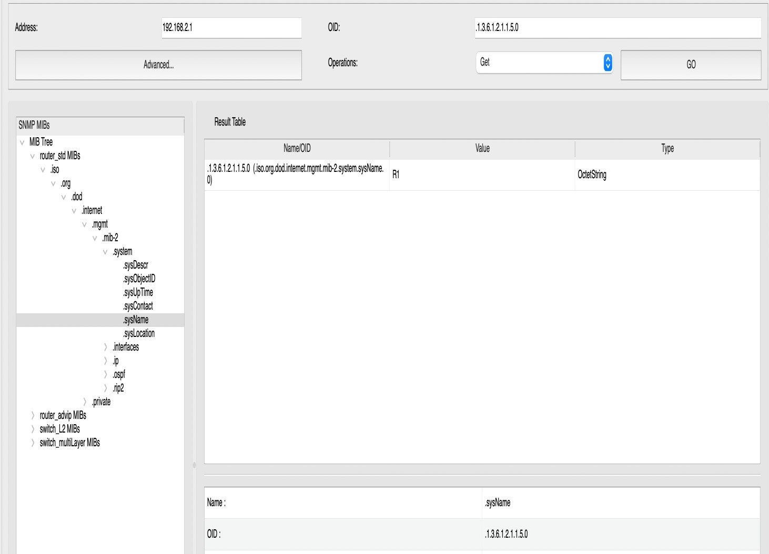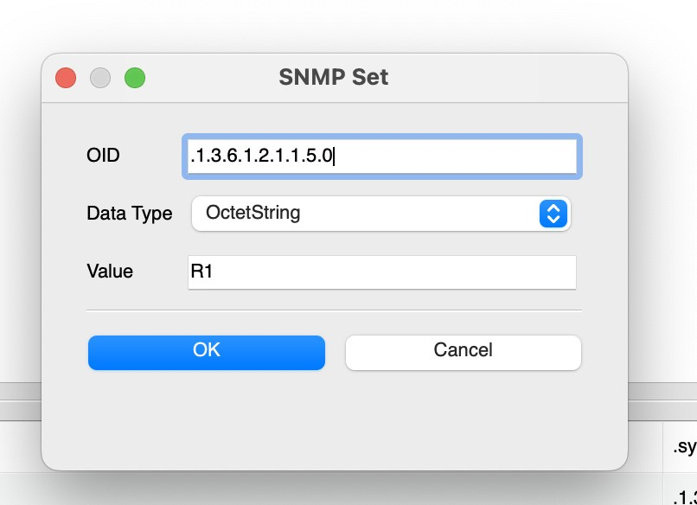

Figure 3: Set command from MIB interface

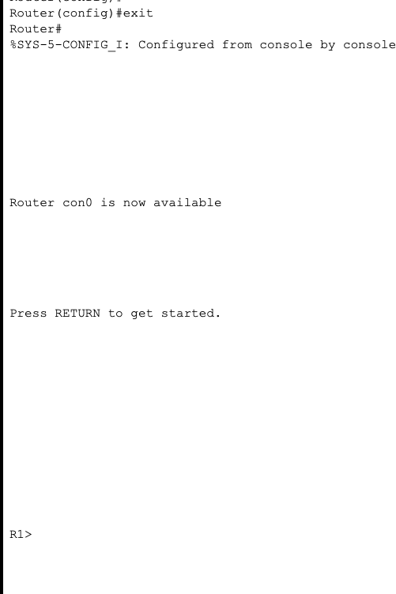

Figure 4: Set Command Result

# Conclusion:

We created a network using a router, switch and PCs. Then implemented SNMP in router configuration using Command line interface and Console. As a result of it we were able to access the MIB from PC to use the SNMP commands like **get** and **set**.

Using get command we retrieved the object name. And by using set command we changed the router name to R1.